Pre-Reading

I know what you did
The first word we have is a set phrase, it is 从 (cong2)。。出来(chu1lai2). 从 as you should know from past lessons means “from.” The second to characters 出来 mean “to come out.” So we can say 他从教室出来， which would mean He came out of the classroom. The next word is 问 (wen4), this again should be review but let’s look at it closer, the inside has a 口so this tell us that it relates to speaking, and the outside is the same as 门, this gives us a clue about its sound. The next word is another phrase, 怎么回事 （zen3mehui2shi4）, the first part of the phrase is 怎么which you remember as “how?” the third character is 回 as in return and the character is 事 as in “things” in an abstract sense, such as things to do and not physical things. Together these four characters ask how something happen, but with an intonation of surprise. For example if you fail test that you thought you should pass, you might ask your teacher 怎么回事，or if you walk into your bedroom and see that it has been destroyed you might ask your roommate怎么回事？The next two characters are 别管 (bie4guan3) 别 you should remember means don’t, so you can say 别说, don’t speak, or you could say 别吃, don’t eat. The second character 管often means manage, but in this case it means to think about, or to care about. So I could say 别管我which would mean don’t bother me, or don’t pay attention to me. 事 is going to be compared with 东西 both of these words means things. However 东西 refers to “stuff” where 事 refers to “things you have to do.” The next word is 解释 (jie3shi4), which simply means to explain something. The first character has three parts to it, on the left side is a 角, on the right side there is a 刀 （knife）and a牛 （cow）, 解 has many meanings, but most of them surround dissection or breaking something apart to better know it. You can see how explain would relate to understanding something better, I remember this character by imagining the knife being used to dissect the cow to understand it better. The next word is 明天 (ming2tian1) this word simply means tomorrow, but it is important to note that sometimes 下 means next as in 下月, and sometimes 明 means next as in 明年, just be aware that for different nouns next and before are not always the same. The next word is 马上 (ma3shang4) which literally means horse on, in English it means “right away.” So your mother might ask you why are not home, you could respond 我马上到了, or I will be home soon. 电话 (dian4hua4) is electric speech or phone, the verb to make a call is 打, so 打电话is to make a call. The next phrase involves the 把 (ba3) structure. Remember 把means to take something and then do something with it, in this reading we will把 something and then 卖给 (mai4) someone else. Pay attention to the difference between 买and 卖 the first one is mai3 it means to buy, the second one is mai4 and it means to sell, we had 给 (gei3), which means give, to indicate who we sell something to. The last phrase is 偷来的 this just simply means stolen from.

Vocabulary/Writing

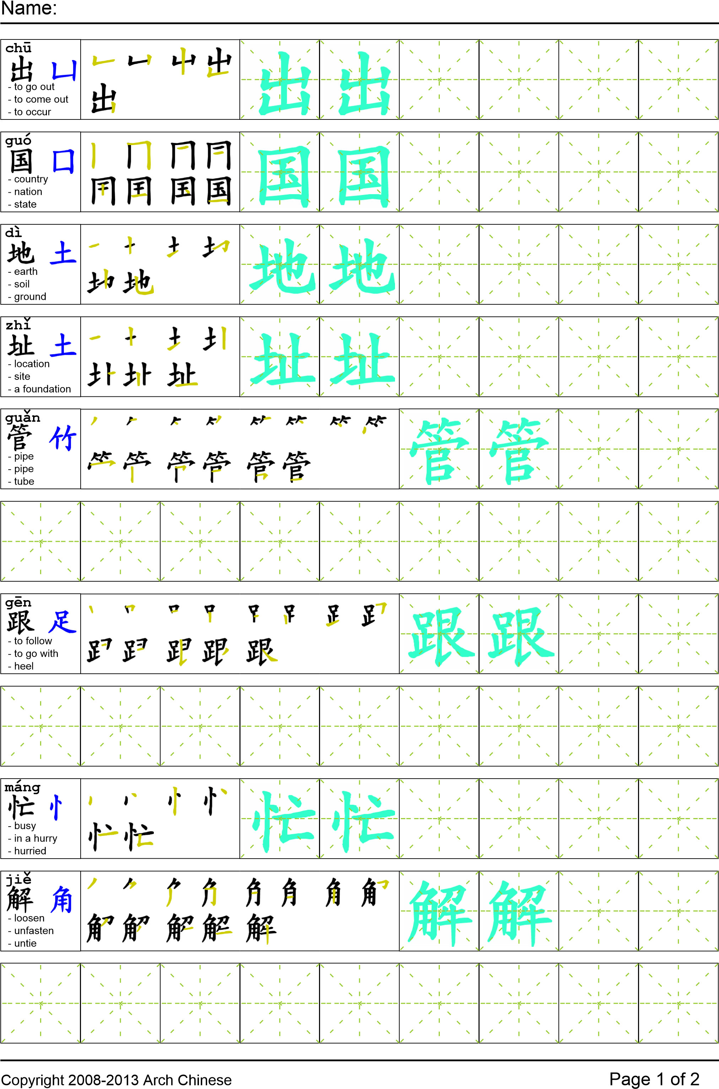
Reading

我妈妈从卧室出来以后，我问她那些国外的地址是怎么回事。她回答“你别管那些事！我现在很忙不能跟你解释！明天我会告诉你！”她说完以后就走了。我马上给我妹妹打电话。我跟妹妹说“我觉得妈妈是小偷她肯定是把偷来的学校用品卖给了别的国家！”

Task Completion

Once all tasks are complete turn the assignment in to collect the points for the project.
Task 1: Trace the vocabulary

Task 2: Answer Comprehension Questions

Task 3: Write the Pinyin for the Reading

Task 4: Translate the Reading into English

Task 5: Record yourself reading the passage twice

Comprehension Questions
- Who does the author think is the thief?
- How can I tell someone to leave me alone?
- What’s the difference between 事 and 东西?
- Write a sentence with马上？

